3.1) ORDER – OC – INPUT SCREEN

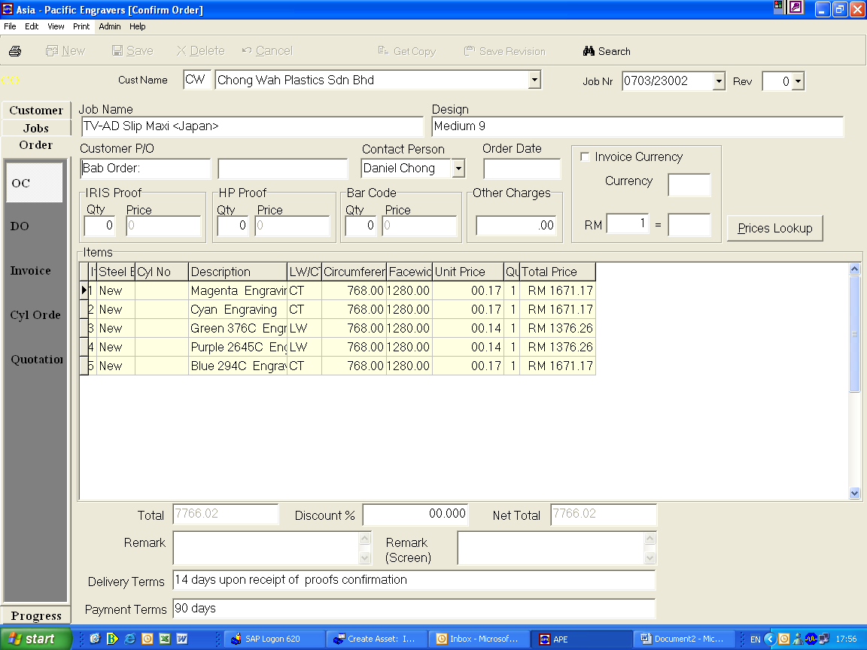

OVERVIEW
To create order confirmation to customer.

RESPONSIBILITY
Respective sales personnel

PROCESS PROCEDURE
Select the customer and the job number, enter the information in the box highlighted. All unit price are pre-set as per first quotation and if certain unit price need to change. We can click “Prices Lookup” button.

This screen allowed us to change the unit price for the particular job.

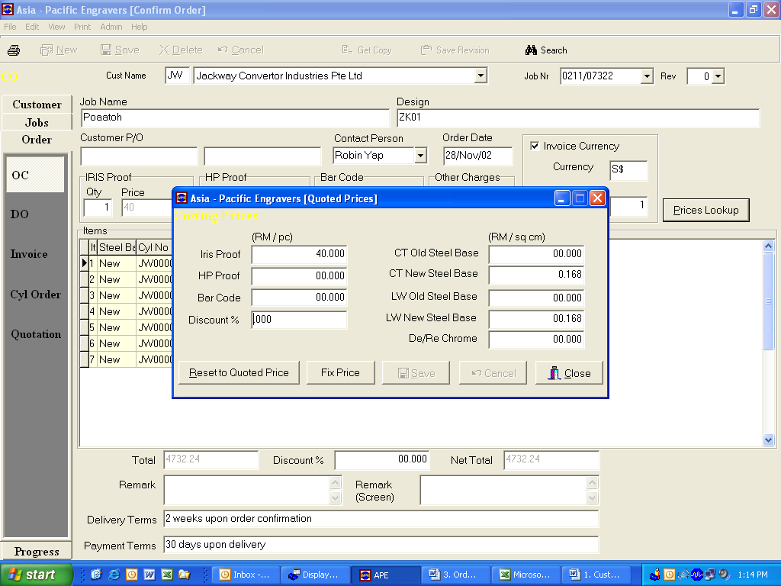

After enter all information, go to PRINT > ORDER CONFIRMATION
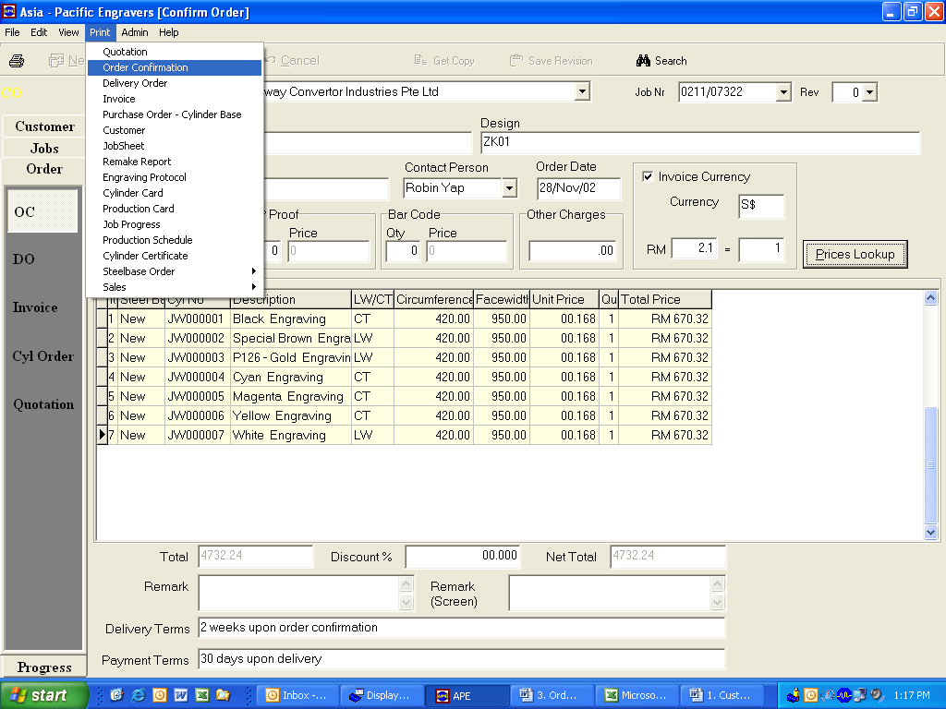

This OC will give to customer to confirm the job.

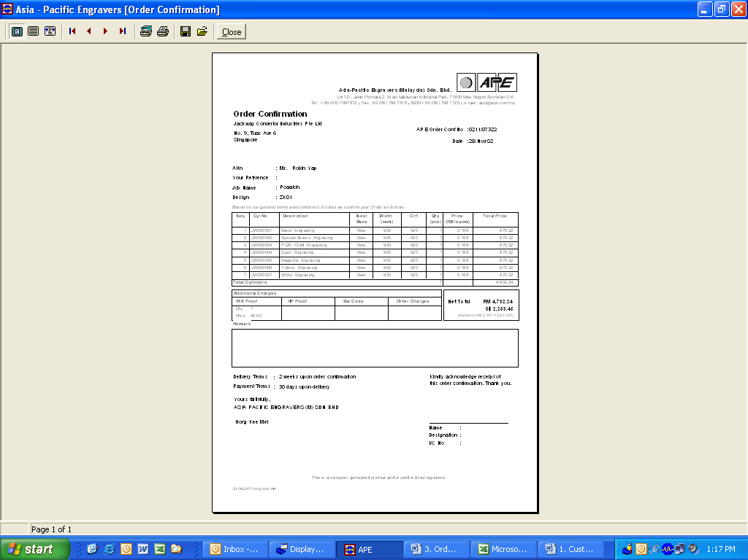

3.2) ORDER – DO – INPUT SCREEN

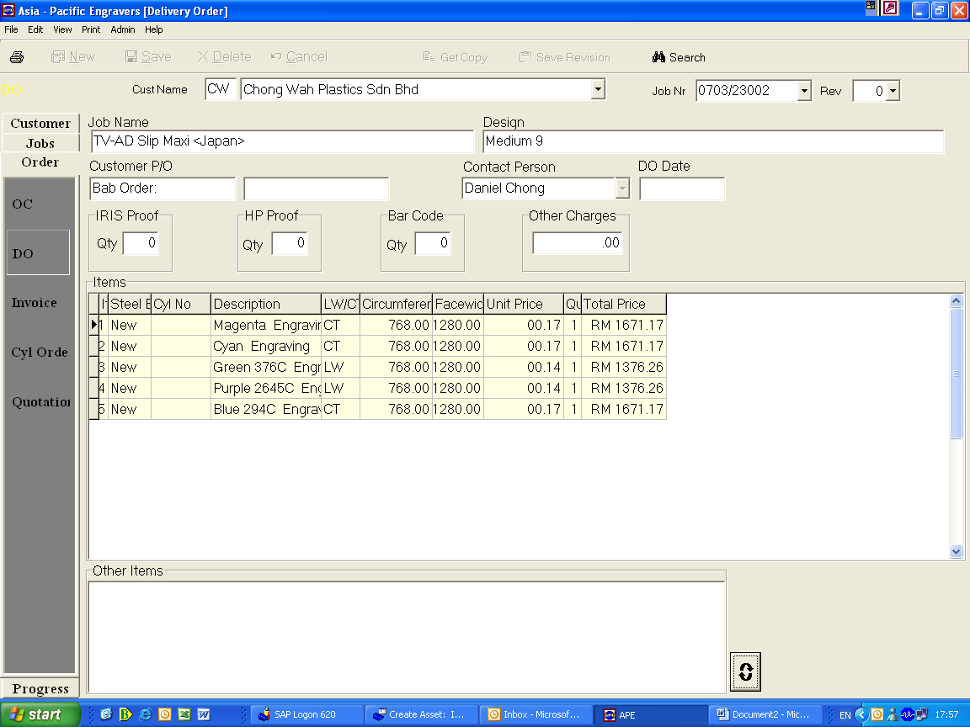

3.3) ORDER – INVOICE – INPUT SCREEN

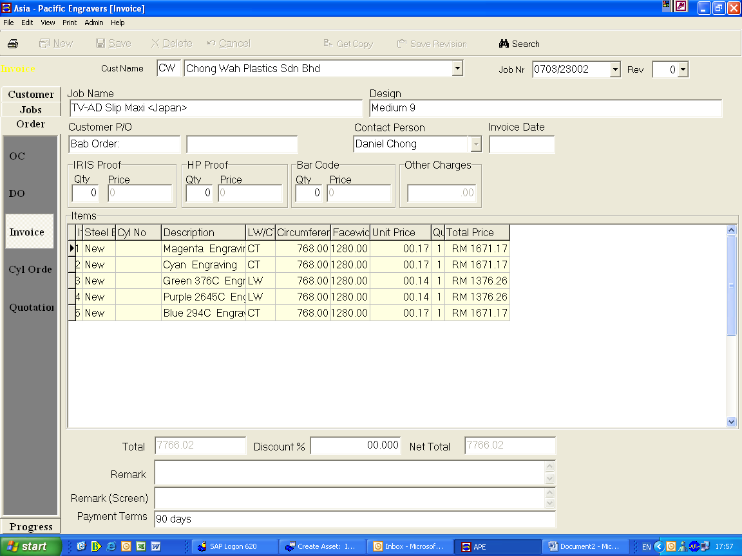

3.4) ORDER – CYL. ORDER – INPUT SCREEN

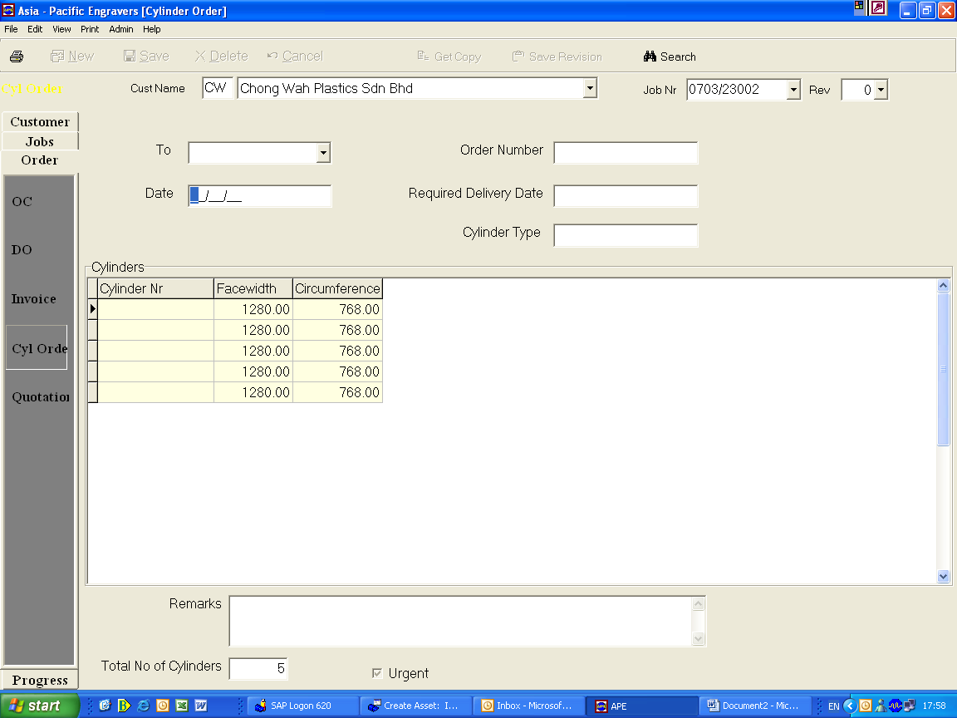

3.5) ORDER – QUOTATION – INPUT SCREEN

